Que and gue spellings

These spellings focus on words ending in the **‘g’** sound spelt **‘gue’** and the **‘k’** sound spelt **‘que’**.

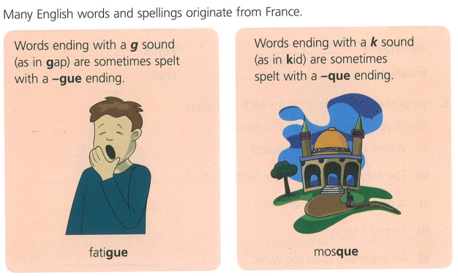

Words to learn:

