**able or ible as a suffix?**

**Most words have ‘able’ as a suffix. Most words that have able as a suffix have a root word that is clear – for example: watch – able = watchable, read – able = readable.**

**If the suffix ible is used, the root is often unclear, but not always; however, there are fewer ible suffixed words – for example: poss – ible = possible,**

**incred – ible = incredible.**

**Here are your ten spellings for this week**

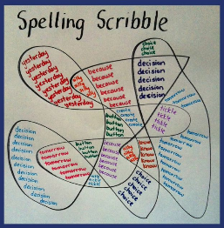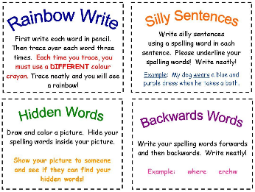**Practise the way you like**

**Laughable**

**Knowledgeable**

**Avoidable**

**Manageable**

**washable**

**Visible**

**Terrible**

**Sensible**

**Edible**

**legible**