The ‘c’ sound spelt ‘que’ and the ‘g’ sound spelt ‘gue’

These spellings focus on words ending in the ‘g’ sound spelt ‘gue’ and the ‘k’ sound spelt ‘que’.
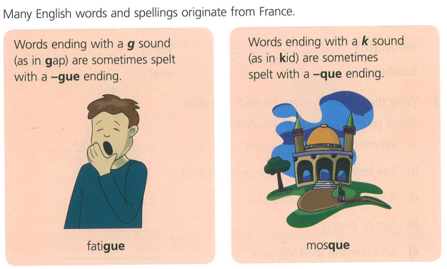

Words to learn:
